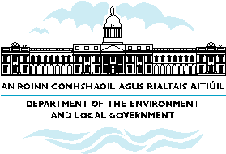

What the NSS means for Waterford City & County
- Waterford’s role as a gateway to be supported by Kilkenny and Wexford as hubs.

- The city will provide a large and skilled population base, substantial capacity for additional residential and employment related functions and an improving transport network.

- There are opportunities to consolidate Waterford City with the River Suir at its heart, supported by the possibilities for developing the North Docks precinct

- Other major urban centres such as Dungarvan and Tramore to support the gateway and form bases of population that will be attractive to investment and employment activities.
- Capability of smaller urban centres needs to be developed further through urban renewal and improvement initiatives.
- Traditional stability and prosperity of villages and rural areas to be assured through mechanisms to enhance the attractiveness of villages to residential and other functions.

