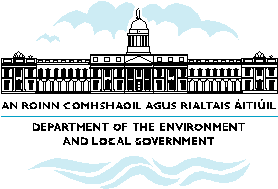

What the NSS means for Limerick city and county

- Limerick/Shannon to continue its development as a national/international gateway.

- Limerick’s critical mass, strategic location, capacity for innovation and connections to the national transport network acts as a magnet for investment into the county, not just Limerick city itself

- Newcastle West performs as strong town with the support of policies and actions to develop its role as a driver of development at the county level.
- There is potential to strengthen smaller urban areas such as Abbeyfeale and Rathkeale which individually and collaboratively can act in partnership with larger urban areas to create further opportunities in the region.
- Provision of supporting development to attract residential, local enterprise and other functions to rural parts of South County Limerick which are experiencing population decline due to agricultural restructuring.
- Enhancement of physical accessibility is needed to develop the potential of underdeveloped estuary areas in West Limerick.

