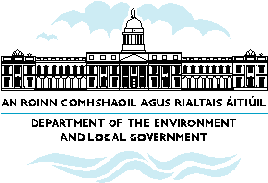

What the NSS means for Donegal

- Letterkenny (working closely with Derry) to be a Gateway.

- Existing relationship between Letterkenny and Derry to be enhanced with a view to strengthening the Northwest. Both can continue to be linked effectively, have complementary strengths and in essence work together as a gateway.

- This will help to drive development through enhanced critical mass and capacity for development in the Northwest

- Important functions for border towns (Ballyshannon, Ballybofey, Bundoran) and other urban areas (Buncrana) to be developed, recognising their tourism, retail and employment potential.
- The national transport network to support the development of economic functions through greater accessibility.
- Scope for development of existing strong tourism, natural resources and enterprise sectors to be sustained in the future.

