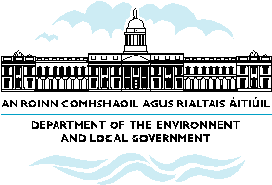

What the NSS means for Meath

- County Meath is an important spatial component of the Greater Dublin Area and the existing spatial structure envisaged for Meath in the Strategic Planning Guidelines is supported by the NSS.

- The NSS outlines a number of additional strategic spatial policy considerations over and above the Strategic Planning Guidelines in terms of Meath’s future relationship with the border and midlands areas.

- Under the NSS, Navan’s role as a Primary Development Centre will need to take account of wider considerations in addition to its role in relation to Dublin.

- The NSS identifies a number of strategic transportation corridors that traverse the county, positioning it strategically between a number of the gateways and creating opportunities for investment and economic activity.
- The NSS identifies a large range of towns of 1,000 to 5,000 population to which additional residential, employment and service functions can be attracted.
- The spatial contrasts between parts of Meath close to Dublin and North Meath are acknowledged in the NSS. Rural areas which have experienced decline relative to rural settlements will have that trend reversed through a focus on boosting the development capacity of smaller villages and rural towns and supporting the housing needs of the rural community.
- The county development plan and County Development Board strategy will play a key role in taking the broad spatial structure and policies in the NSS and applying them in more detail to County Meath.

