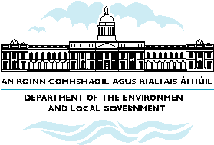

What the NSS means for Longford

- Longford as the County town will act as an economic driver for County Longford and the wider Midlands area capitalising on its strategic location on national road and rail links connecting the Midlands to the North West and Border regions.

- Longford’s role can be enhanced in competitive terms to drive development at the county level. Planning frameworks to co-ordinate development and achieve good quality urban design in new development will support the competitiveness and attractiveness of Longford.

- The NSS outlines opportunities to strengthen other urban centres in Longford through physical and townscape improvements, facilities for enterprise and enhanced transport links. Harnessing these opportunities means that smaller towns will complement the attractions of larger towns by having an attractive environment for a range of residential, commercial and local enterprise activities.
- Longford has substantial potential for tourism and recreational amenities-related development which can be harnessed to diversify the rural economy creating local employment opportunities for local people.

- Key features of Longford’s potential relate to unspoilt landscapes and inland waterway networks.

