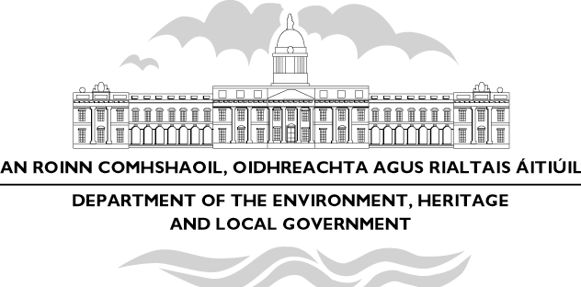

Minister Dick Roche Hosts National Launch Of Regional Planning Guidelines

“Regional planning guidelines to play a key role in linking strategic planning at regional and local level to decision-making on our national investment priorities”

Funding of €6.8m for the Ennis Water Augmentation and €9m for the Shannon Town Sewerage Scheme

“Regional planning guidelines seek to build on the strengths of regions and make them more competitive. They are also about ensuring a high quality urban environment, as well as vibrant rural areas.” Minister Dick Roche T.D. said today (4 February).

Mr. Roche, Minister for the Environment, Heritage and Local Government, was speaking at the national launch in Ennis, Co.Clare of the regional planning guidelines which have been put in place in each region throughout the country.

Speaking at the launch, Minister Roche highlighted the fact that for the first time Ireland now has in place the entire hierarchy of strategic plans envisaged under the Planning and Development Act, 2000. These range from the National Spatial Strategy at national level, to regional planning guidelines at regional level, and to city, town, county and local area plans.

On publishing the National Spatial Strategy in late 2002, the Government emphasised the need to put regional planning guidelines in place as quickly as possible to give effect to the NSS at regional level.

“The preparation of the regional planning guidelines we are launching to-day demanded an ability to take a broader and longer term view, something that we have not always been so good at in the past. Adopting these guidelines shows, however, that we have grown to appreciate the value of working together in partnership and taking a long-term view of where we want to go in our development. I wish to take this opportunity to congratulate all of those involved in the process at regional and local level for responding so effectively and quickly to the challenge involved in putting these guidelines in place.” said the Minister.

The Minister added that achieving the economic and social potential of our regions can only happen if the various elements in different areas, such cities, larger and smaller towns and associated rural areas, collaborate more closely on mutually beneficial strategies for development.

He pointed also to encouraging evidence already of concrete responses to the NSS and the regional planning guidelines across the public and private sectors. A highly significant example of central Government responding positively to strategic planning at local level came last year with the announcement of a €90 million investment in the Mallow-Cork-Midleton commuter rail system, which will open up a new 20,000 house development corridor for Cork over the next 15 years or so. The rail announcement follows through on the Cork Area Strategic Plan and shows investment in critical infrastructure being prioritised to encourage new and innovative development patterns.

The Minister also announced an investment package of €6.8 and €9m for the Ennis Water Augmentation Scheme and Shannon Town Sewerage Schemes respectively. Referring to the designation of Ennis as a hub under the NSS the Minister said “I am pleased to announce this important funding which will assist in the future development needs of Ennis and in attracting focused investment into the area. In the case of Shannon the investment will further underpin its role as part of the Limerick – Shannon Gateway.”
”

At the launch the Minister said “Above all, I want to leave people with the clear message that the Government will be working pro-actively to support the implementation of the regional planning guidelines. However in doing that, the reciprocal challenge for regional and local authorities will be to champion the messages in the guidelines, to put in place the implementation measures promised in the guidelines and to take the necessary decisions focused on the investment priorities for the regions”.

In concluding the Minister said he was “confident that the Government will find a willing and able partner in the regional and local authority structure in delivering more balanced regional development in the future”

Media queries:
Press and Information Office
Tel: (01) 888 2638 (direct)
(01) 888 2000
E-Mail: press-office@environ.irlgov.ie
Web site: www.environ.ie

