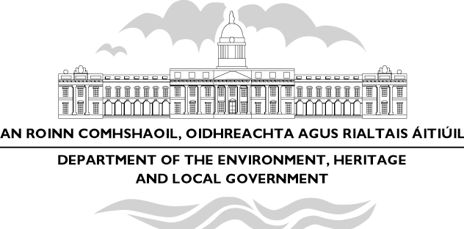

Roche launches finalised Planning Guidelines on Rural Housing

“ Planning for the provision of rural housing must recognise the strong and continuing tradition of people living in rural areas and should promote and support vibrant rural communities” the Minister for the Environment, Heritage and Local Government Mr Dick Roche TD., said today (13/04/05). The Minister was speaking at the launch of the guidelines on sustainable rural housing which he has now finalised for publication.

The final statutory guidelines follow through on the draft guidelines for Planning Authorities on Sustainable Rural Housing published in March 2004 to give all those interested an opportunity to comment before the guidelines were finalised in statutory form.

“ Overall, the broad thrust of the guidelines remains unchanged” said the Minister, “reasonable proposals on suitable sites for persons who are part of and contribute to the rural community must be accommodated. In other words, the guidelines represent a presumption in favour of quality one off housing for rural communities, provided proposals meet normal standards in relation to matters such as the proper disposal of waste water and road safety.”

The guidelines are a material consideration both in relation to development plans and in the consideration of planning applications. Planning authorities are required to review and vary their development plans, where necessary, to ensure that their policies on rural settlement are consistent with the policies set out in the guidelines.

105 submissions in relation to the draft guidelines were received by the Department from interested organisations and individuals.

Many suggestions for clarifying or improving the guidelines have been incorporated in the guidelines in the final statutory form in which they are now being published.

Main differences between draft guidelines and final statutory guidelines

Most of the submissions welcomed the broad thrust of the draft guidelines.

Some of the main changes made in the proposed final version of the guidelines as compared with the March 2004 draft are as follows:

Improving Services to Applicants

A new section has been added to put stronger emphasis on a better and more courteous service from planning authorities and improved co-operation between planning authorities and applicants, particularly at the pre-planning phase of applications.

Returning Emigrants

The guidelines make absolutely clear that the housing needs of emigrants who now wish to return to their home places on retirement or for other reasons should be facilitated.

Exceptional Health Circumstances

This is a new provision which indicates that planning authorities should grant permission in cases where exceptional health circumstances, as certified by a doctor and the relevant disability organization, may require a person to live in a particular environment or close to family support.

Design Aspects

The guidelines stress the need for a balanced and informed approach by planning authorities in assessing the design aspects of proposals and not to be overly-prescriptive e.g. putting a ban on brick in all cases, or requiring that all roofs be of a particular coloured slate.

Rural housing development in Special Areas of Conservation and other designated areas

While the guidelines continue to make clear that statutory designation is not intended to operate as an inflexible constraint on rural housing development, it is also now being made clear that planning authorities, before granting approval to development in such an area, must be satisfied that the integrity of the area will not be adversely affected.

Strengthening Rural Villages and Smaller towns

The purpose of some new text on this issue is to mention that, as well as housing needs in rural areas, which is what the guidelines are mainly about, housing also needs to be promoted in smaller towns and rural villages to ensure that they offer attractive and affordable housing options.

Holiday and Second Home Development

The section on holiday and second homes has been expanded to make a better distinction between the different types of development in this category, including the growing trend of ‘resort’ type development when old estates are developed as golf courses with associated hotel and residential development, and the need for planning policies to distinguish between these different types of development

A copy of the finalised guidelines is available for download from the Department’s website www.environ.ie or from www.irishspatialstrategy.ie A printed copy will be available shortly.

Following the publication of the guidelines the Department is organising, in conjunction with the local authorities and planning institutes, a series of regional seminars for planners on the practical implementation of the guidelines. The seminars will provide practical advice on the implementation of the core messages of the guidelines, including preparation of development plan policies, providing better support and advice to applicants and more efficient and comprehensive consideration of planning applications.

ENDS

Media queries:
Press and Information Office
Tel: (01) 888 2638 (direct)
(01) 888 2000
E-Mail: press-office@environ.irlgov.ie
Web site: www.environ.ie

